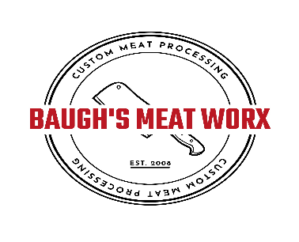
B tg
5920 Old Buckingham Rd. (804)492-9902
Powhatan, Va 23139 Baughsmeatworx@gmail.com
BEEF CUT SHEET – 1/4 SHARE
Name: ________________________________________________________________ Date Killed: ________________
Address:_________________________________________________________________ Date Processed:_____________
________________________________________________________________ Live Weight:________________
Phone #__________________________________________________________________Hanging Weight: ____________
Kill & Cool: $100 – Hanging Weight: $.85/lb
Cuts |  |  |  | Ground Beef (Packs)  30 – 40 Lbs |  |  | Steak
 | Arm Roast | X |  | Ground Beef | X |  | Thickness | Steaks per Pack
CHUCK | Chuck Roast | X |  | Packs | 1 lb or 2 lb |  | ¾ inch | 1 per pack
 |  |  |  | Double Ground | .25 |  | or | or
 |  |  |  | Fat Percentage |  |  | 1 inch | 2 per pack
RIBS | Ribeye Steak | X |  |  |  |  | Roast Weight
RIBS | Short Ribs | X |  |  |  |  | 3 LB.
LOIN | T-Bone Steak | X |  | Aging (Days) : | 21 |  | *Additional Charge
LOIN | PorterhouseSteak | X |  |  |  |  | Cube Steak - $.50 /lb  Stew Meat - $1/lb
LOIN | Top Sirloin Steak | X |  | NOTE  Neck and back bone CANNOT b e returned to owner  $20 FEE FOR LATE CUT SHEETS
ROUND

ROUND |  |  |  | Special Instructions |  |  | Cart #
ROUND | Top Round Roast | X |  |  |  |  | OFFICE USE  Kill & Cool $ ___________  Hanging Wt $ ___________  Extras $ ___________  Finished Wt ___________  TOTAL _______________  QUARTER BEEF CUT LIST 2025
ROUND | Bottom Round Roast | X
ROUND | Eye of Round Roast | X
ROUND | Sirloin Tip Roast | X

