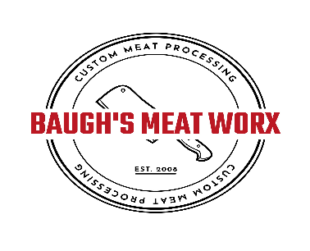
tg
5920 Old Buckingham Rd. (804)492-9902
Powhatan, Va 23139 Baughsmeatworx@gmail.com
_____WHOLE SHARE BEEF CUT SHEET _____ 1/2 SHARE

Name______________________________________________________________ Date Killed _______________________
Address____________________________________________________________ Date Processed____________________
City/State/Zip _______________________________________________________ Phone ___________________________

Cuts (X) |  |  |  | Ground Beef (Packs) |  |  | Steak
 | Chuck Roast |  |  | Burger | 1 lb 2 lb |  | Thickness | Steaks per Pack
CHUCK | Arm Roast |  |  | Double Ground | .25
 | Brisket |  |  | Fat percentage
 | Skirt Steak
RIBS | Ribeye | Bone/Boneless |  | Save Fat | Yes/ No |  | Roast Weight
RIBS | Short Ribs |  |  | Soup Bones | Yes/ No
RIBS | Plate Ribs
LOIN | T-Bone |  |  | Aging (Days) : | 21 |  | *Additional Charge
LOIN | Porterhouse |  |  |  |  |  | Cube Steak - $.50 /lb  Stew Meat - $1/lb  Fajita Meat - $2/lb
LOIN | New York Strip
LOIN | Filet Magnon
LOIN | Flank Steak
LOIN | Hanger Steak
LOIN | Top Sirloin
ROUND

ROUND | Top Round | Roast/Steaks |  | Special Instructions |  |  | OFFICE USE
ROUND | Eye of Round | Roast |  |  |  |  | Live Wt $ ________________  Hanging Wt $______________  Finished Wt _________________  CUTS _______________________  ____________________________  GRIND______________________
ROUND | Bottom Round | Roast/Steaks
ROUND | Sirloin Tip | Roast/Steaks
OTHER | Heart |  |  | *Stew Meat | _____# lbs |  | BEEF CUT SHEET 2025
OTHER | Liver |  |  | *Fajita Meat | _____# lbs
OTHER | Tongue |  |  | *Cube Steak | _____# lbs
OTHER | Oxtail

